EXPERIMENT 1 – FIND-S ALGORITHM
Aim
To implement and demonstrate the FIND-S algorithm for finding the most specific hypothesis based on a given set of training data samples.
Procedure
1. Define the training dataset.
2. Initialize the hypothesis with the most specific values.
3. Consider only positive training examples.
4. Compare positive examples with the hypothesis.
5. Replace differing attributes with '?'.
6. Ignore negative examples.
7. Display the final hypothesis.

Program :1
data = [
['Sunny', 'Warm', 'Normal', 'Yes'],
['Sunny', 'Warm', 'High', 'Yes'],
['Rainy', 'Cold', 'High', 'No'],
['Sunny', 'Warm', 'High', 'Yes']
]

# Initialize the hypothesis
h = ['0'] * (len(data[0]) - 1)

# Apply Find-S algorithm
for row in data:
if row[-1] == 'Yes':
if h[0] == '0':
h = row[:-1]
else:
for i in range(len(h)):
if h[i] != row[i]:
h[i] = '?'
print("Current Hypothesis:", h)

print("\nFinal Hypothesis:", h)

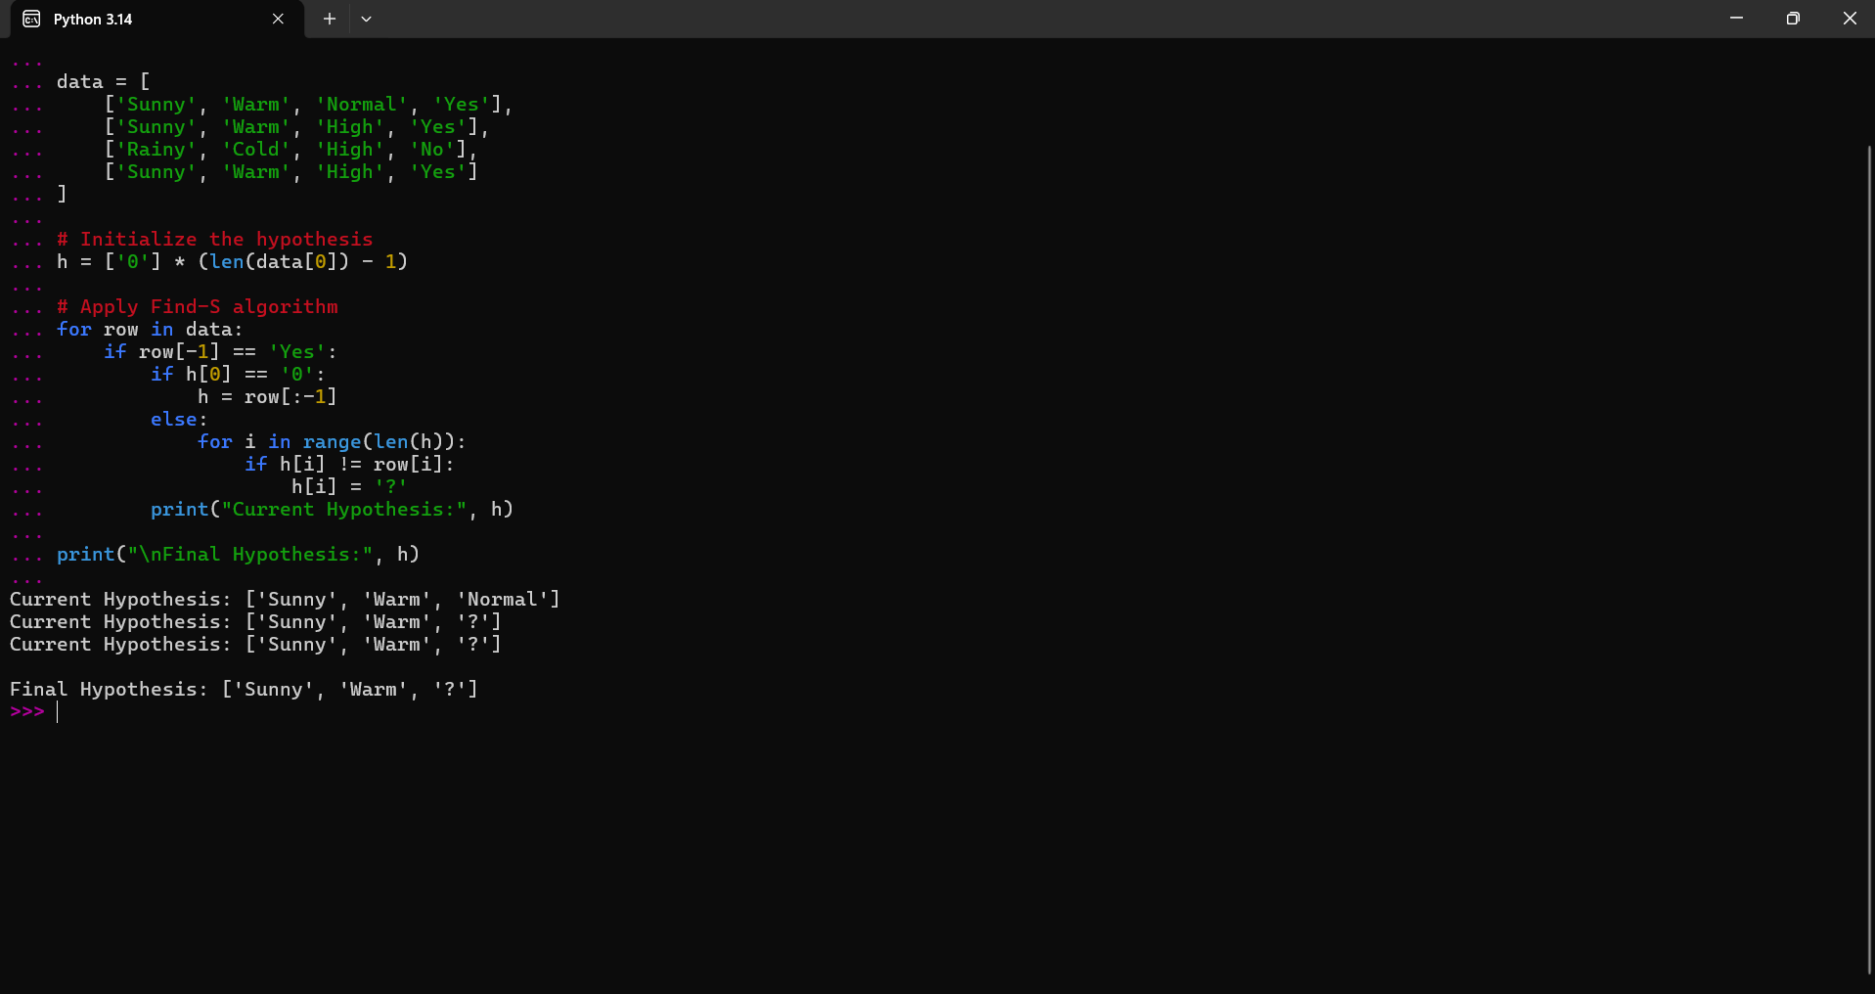
Program : 2 Play Tennis
data = [
['Sunny', 'Warm', 'Normal', 'Strong', 'Warm', 'Same', 'Yes'],
['Sunny', 'Warm', 'High', 'Strong', 'Warm', 'Same', 'Yes'],
['Rainy', 'Cold', 'High', 'Strong', 'Warm', 'Change', 'No'],
['Sunny', 'Warm', 'High', 'Strong', 'Cool', 'Same', 'Yes'],
['Rainy', 'Warm', 'Normal', 'Weak', 'Warm', 'Same', 'No'],
['Sunny', 'Warm', 'Normal', 'Weak', 'Warm', 'Same', 'Yes']
]

hypothesis = ['0'] * (len(data[0]) - 1)

for row in data:
if row[-1] == 'Yes':
if hypothesis[0] == '0':
hypothesis = row[:-1]
else:
for i in range(len(hypothesis)):
if hypothesis[i] != row[i]:
hypothesis[i] = '?'
print("Current Hypothesis:", hypothesis)

print("\nFinal Hypothesis:", hypothesis)
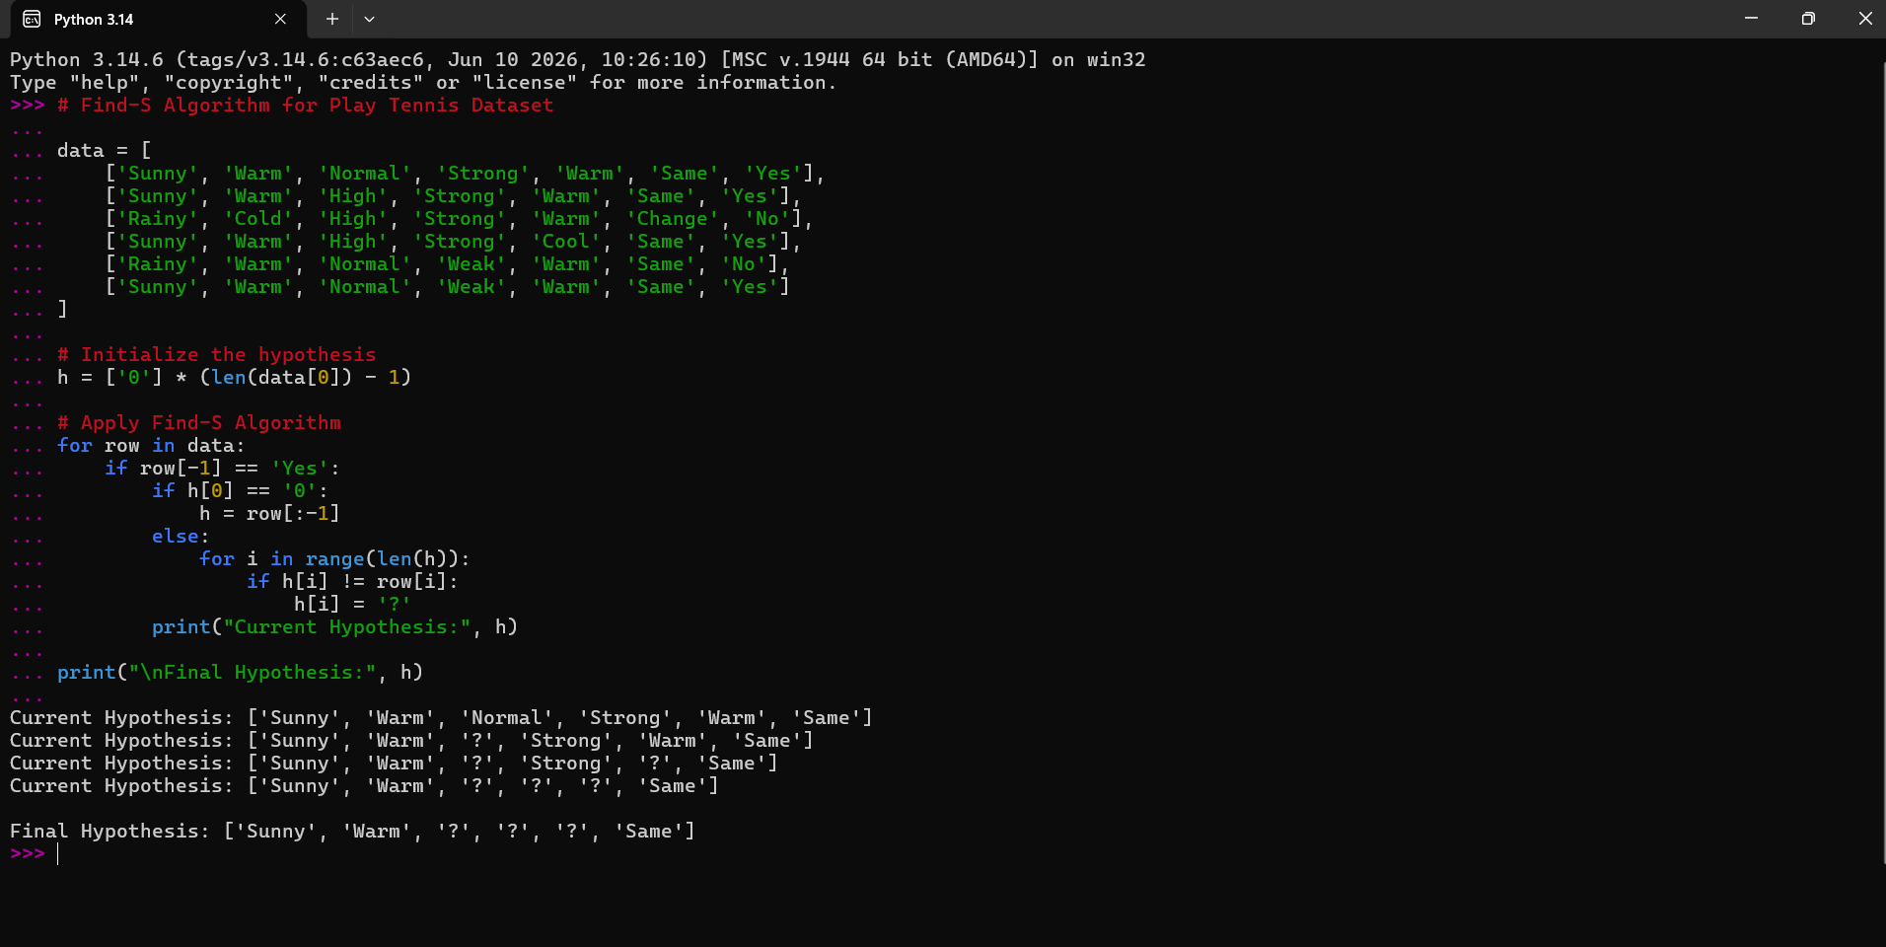
Program : 3 Loan Approval

data = [
['High', 'Good', 'Permanent', 'Yes', 'Young', 'Yes'],
['High', 'Good', 'Permanent', 'No', 'Middle', 'Yes'],
['Low', 'Poor', 'Temporary', 'No', 'Young', 'No'],
['Medium', 'Good', 'Permanent', 'Yes', 'Middle', 'Yes'],
['High', 'Average', 'Temporary', 'Yes', 'Old', 'No'],
['High', 'Good', 'Permanent', 'Yes', 'Middle', 'Yes']
]

hypothesis = ['0'] * (len(data[0]) - 1)

for row in data:
if row[-1] == 'Yes':
if hypothesis[0] == '0':
hypothesis = row[:-1]
else:
for i in range(len(hypothesis)):
if hypothesis[i] != row[i]:
hypothesis[i] = '?'
print("Current Hypothesis:", hypothesis)

print("\nFinal Hypothesis:", hypothesis)
